Reverse Chronology Report Guide
Reverse chronology begins with a contemporary focus and follows logical pathways backwards to learn about relevant historical, cultural and traditional styles and art forms. It follows a cause-and-effect pathway to understand historical influences on artists, styles and approaches.
Cognitive Verbs: implement, apply, analyse, interpret, evaluate, justify, realise
Length: 1000 – 1500 words

Reverse Chronology Report structure includes:
sub-heading | approximate  word length | - Context – include inquiry question from task sheet –  - How do artists use people, places or objects as symbols to express personal viewpoints through their artworks?  - Introduce the contemporary artist from the suggested artist list.  - Introduce the two supporting artists or influences. (Note: one must be an artist)  - Explain contexts (contemporary/personal, etc.)
introduction | 100
overview of  key artists | 50 | - A brief outline of the links between the focus artist and the other two artists (or influences)
key artist #1  artwork #1 | 250 | - Briefly describe the background of this artist such as country of origin, philosophy and influences  - State the artwork’s title, date, media, dimensions  IN-TEXT REFERENCE ALL RESEARCH INFORMATION!  - Explain the ‘lens’/viewpoint they work within and the context (contemporary/personal, etc.)  - Describe the subject matter of the artwork  - Analyse the techniques, media, and processes used to create the artwork  - Analyse relevant visual language (elements and principles)  - Interpret the use of symbolism and use of objects; explain their meaning and link to the inquiry question (eg. How do artists use objects as symbols to express personal viewpoints in their artworks?)
key artist #2  artwork #2 | 250 | - Briefly describe the background of this artist such as country of origin, philosophy and influences  IN-TEXT REFERENCE ALL RESEARCH INFORMATION!  - State the artwork’s title, date, media, dimensions  - Explain the ‘lens’/viewpoint they work within and the context (contemporary/personal, etc.)  - Describe the subject matter of the artwork  - Analyse the techniques, media, and processes used to create the artwork  - Analyse relevant visual language (elements and principles)  - Interpret the use of symbolism and use of objects; explain their meaning and link to the inquiry question (eg. How do artists use objects as symbols to express personal viewpoints in their artworks?)  - Evaluate and justify their link to artist 1
key artist #3  artwork #3 | 250 | - Briefly describe the background of this artist such as country of origin, philosophy and influences  IN-TEXT REFERENCE ALL RESEARCH INFORMATION!  - State the artwork’s title, date, media, dimensions  - Explain the ‘lens’/viewpoint they work within and the context (contemporary/personal, etc.)  - Describe the subject matter of the artwork  - Analyse the techniques, media, and processes used to create the artwork  - Analyse relevant visual language (elements and principles)  - Interpret the use of symbolism and use of objects; explain their meaning and link to the inquiry question (eg. How do artists use objects as symbols to express personal viewpoints in their artworks?)  - Evaluate and justify their link to artist 1
conclusion | 100 | - Summarise the key points of your report regarding the links between each of the artists (see step 2 – key artists section)  - Summarise your justification of their personal viewpoints and use of objects
Example of ‘High-Level’ Student Response
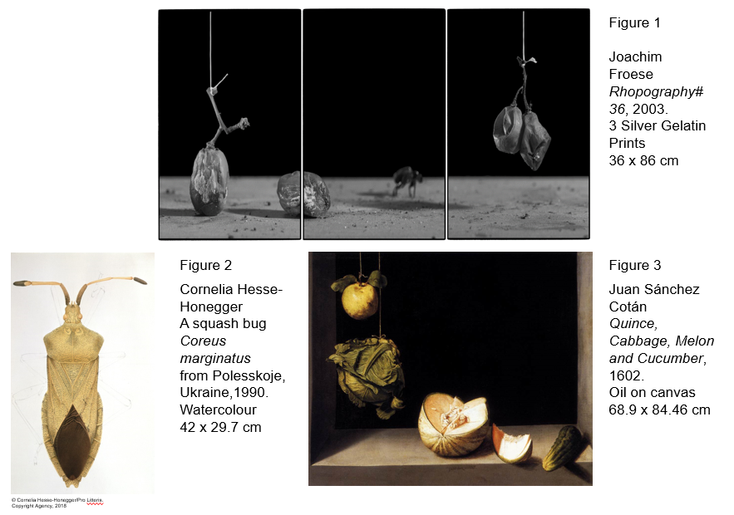
introduction | Artists devise unique viewpoints or lenses that challenge the audience to consider their connection to images, objects and perspectives. Artists also work within different contexts to provide a frame of reference for their work. This report will respond to the inquiry question, “How do artists use objects as symbols to express personal viewpoints through their artworks?” Joachim Froese, whose work is currently on display in the APT9 exhibition at the Queensland Gallery of Modern Art, uses photography to present imagined narratives as truth. He works within a personal context, referencing the traditions of still life, landscape and the portrait. In combination with an inquiry into Froese’s work, this report will establish links with two other artists whose subject matter and use of objects influence Froeses’. They are Cornelia Hesse-Honegger and Juan Sanchez Cotan. (134) | annotate key features of report
overview of key artists | The key artists have each expressed a personal viewpoint by using or manipulating humble, found objects. In contrast to Froese’s, Hesse-Honegger’s work objectively illustrates insects, to point out the harm of radiation. Juan Sánchez Cotán’s oil painting practice was innovative for his time because his subject matter was humble food. Their three works are linked by the artists’ close observation of objects and an illusion of realism. Froese is directly influenced by Sánchez Cotán’s still life images and he uses insects, which provides a link to Cornelia Hesse-Honegger’s practice whose focus is the impact of radioactive pollutants on insects. (99)
Key artist #1 | Joachim Froese’s Rhopography series consists of a series of three silver gelatin prints, measuring 36 by 86 cm. Created in 2003, Rhopograhy #36 shows Froese using a contemporary lens to reinterpret the historical genre of still-life painting. The title ‘Rhopography’ references the humble subject matter of Froese’s photographs. His focus is the presentation of truth through the medium of photography. He manipulates found objects to convey his personal view that every photograph is made from the subjective view of the photographer, even if it is documenting an event. (88)
artwork #1 | Froese composes his black and white photographs into narratives like a storyboard. He does not crop or digitally edit his images. Instead, he uses traditional darkroom (analogue) techniques which leave visual clues that “signify truth”. These clues “include black borders around each print and the sharp focus” (Froese, n.d.). Due to these devices, the audience is challenged to consider the existence of a scene like the one depicted in Rhopography #36 (figure 1).  This is a triptych in which the ‘action’ mostly occurs within the narrow depth of field along the front of the picture plane. The dark background, mouldy grapes and the blurry, scurrying insect suggest a secretive and dirty setting, like behind the fridge. Froese is working in miniature with decomposing grapes and an unidentifiable insect which the audience knows is very small. These tiny objects are presented in large scale, thereby challenging audience expectations because insects and grapes are normally expected to be tiny and insignificant. This work is an early example of Froese’s imagery. It shows him using objects deliberately to pose questions about the essence of the human condition and relationships. (186)
key artist #2 | Cornelia Hesse-Honegger’s work can be read through a cultural context as a response to the impact of nuclear energy. The focus of her practice is the impact of radioactive pollutants on insects. She made extensive studies of insects in affected areas between the late 1980s until 2007. She “made over 300 detailed drawings of damaged or malformed insect bodies, wings, feelers, asymmetric body sections, black spots and ulcers” (Hesse-Honegger, 2008). She uses found objects (insects) to express her personal viewpoint about the danger of nuclear power. Her work challenges audiences to question the safety of nuclear power because the insects make us wonder what the impact could be on human beings. (111)
artwork #2 | Hesse-Honegger uses a binocular microscope to observe her subjects then makes detailed watercolour sketches (HesseHonegger, n.d.). Figure 2 is an example of her illustrations. This insect has a malformed left antenna. Contours outlining the legs are visible in the image but have not had colour, tone or texture applied, whereas the body, head and antennae are complete. This signifies to the viewer that the legs are less important to the researcher than the more resolved part of the drawing and is in keeping with the genre of scientific illustration. In scientific illustration, realism is important because the drawing is an official record. (102)
reference list | Daw, R. (2000, December). Rhopography. Artlink (20:4). Retrieved February 15 , 2018, from https://www.artlink.com.au/articles/2485/rhopography/  Fitzgerald, C. (1997). heteroptera: Carlow Visualise. Retrieved February 20, 2018, from http://www.cathyfitzgerald.ie/heteroptera-Carlow-Visualise  Froese, J. (n.d.). Rhopography 1999-2003. Retrieved February 15, 2018, from Joachim Froese: http://www.joachimfroese.com/rhopography.html  Hesse-Honegger, C. (n.d.). Retrieved February 20, 2018, from Cornelia Hesse-Honegger: www.wissenskunst.ch/uk/completed-studies/europe/radiation-contaminated-areas-in-europe/  Hesse-Honegger, C. (2008, April 18). Malformation of True Bug (Heteroptera): a Phenotype Field Study of the Possible Influence of Artificial Low-Level Radioactivity. Chemistry and Biodiversity, Vol. 5(4), pp. 499-539. doi:doi: 10.1002/cbdv.200800001  Schama, S. (2010). Hang-Ups: essays on painting (Mostly). Random House  The San Diego Museum of Art. (n.d.). Still Life with Quince, Cabbage, Melon, and Cucumber. Retrieved March 1, 2018, from The San Diego Museum of Art: http://collection.sdmart.org/Obj1358?sid=7431&x=33070

